14.71: The ship will rise; the total mass of water displaced by the barge-anchor combination must be the same, and when the anchor is dropped overboard, it displaces some water and so the barge itself displaces less water, and so rises.
To find the amount the barge rises, let the original depth of the barge in the water be are the masses of the barge and the anchor, and A is the area of the bottom of the barge. When the anchor is dropped, the buoyant force on the barge is less than what it was by an amount equal to the buoyant force on the anchor; symbolically,

which is solved for

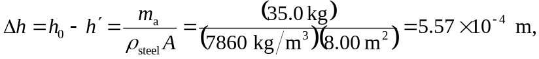

or about 0.56 mm.

